RC tutorial 006 Making cable ducts by offsetting a track  
=============================================

Revised 2019-12-15

* This tutorial's goal is to teach you how to offset a track and produce cable duct alignments.
* Assumed skills: Basic Lua programming, 3D, alignments and the RC alignment manager.
* Assumed Railway skills: None
* Time to spend here: Expert: 20 minutes. Intermediate: 45 minutes. Beginner: 1,5 hour.
* Notice to users with non-English versions of AutoCAD – see footnote[1].
* This tutorial was prepared using software release 2019.1.1492 with Norwegian DNA version “2019.1-beta(b)”,”NO-BN;NO-0001;2019-09-28T20:19:00+01:00;2019.1”.
* Note: If you are using AutoCAD version 2017 or older, then open the 2013-format version of the tutorial DWG file.

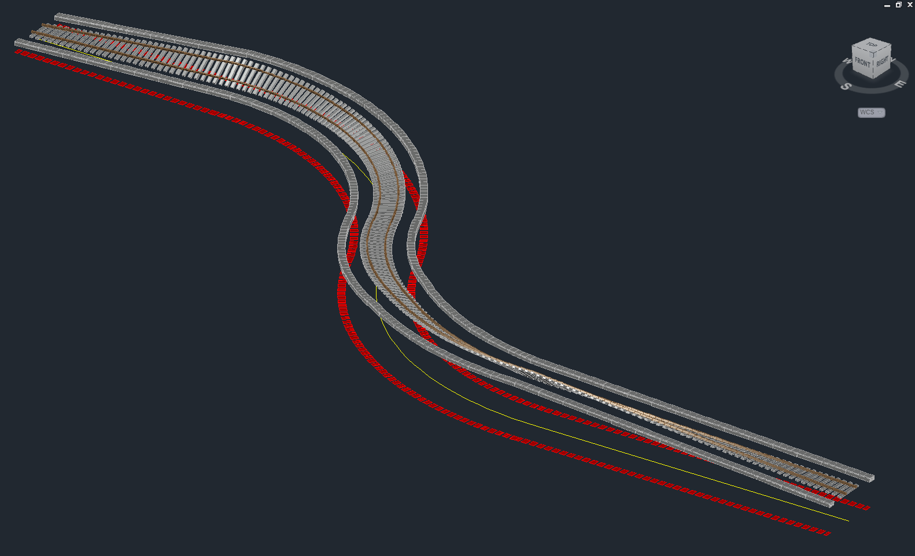

1. Start AutoCAD with RailCOMPLETE, then open the ‘General Tutorials’ folder and locate the DWG file named after this tutorial. You can either type RC-ShowGeneralTutorials or you can locate the button below the RC logo in the upper left corner of your AutoCAD window.
2. Cable ducts use sampled formulas in order to add variations to for instance the elevation of a cable duct along its length. Consult other tutorials to learn more about sampled formulas.
3. **Offset3D.Z**: Cable ducts are placed with the centre bottom of the duct element (usually a concrete or a plastic pre-fabricated element) on the duct’s alignment axis, in the absence of other factors. But if the cable duct is supposed to follow the extra elevation of the closest rail, then we will add an offset in the Z direction being the same as the extra elevation that the closest rail has received. The formula is:  
     
     
   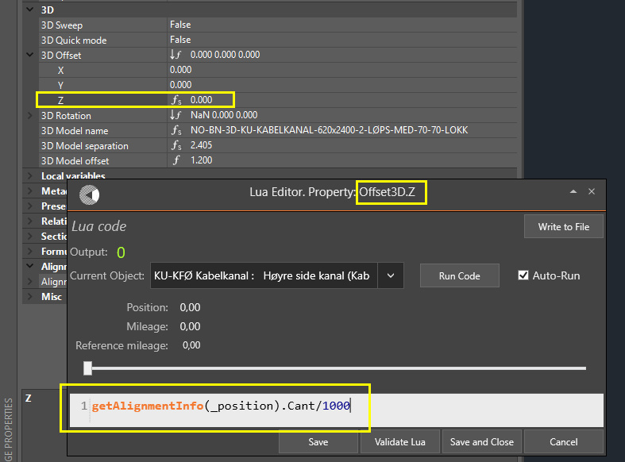  
     
   Note the use of the intrinsic (predefined in RailCOMPLETE) variable ‘**_position**’. It acts as a kind of “cursor” which slides from position zero to position Length2D, i.e. from start to end of the alignment as it has been laid out in the XY plane (the so-called geometry).
4. **Rotation3D.X**: If a cable duct is laid out with varying elevation (Z-coordinate), then we add a rotation around the local X-axis in order to have a smooth gradient. We also add the effect of the extra lift due to ‘Cant’, i.e. in order to follow the extra lift of the closest rail. The formula is:  
     
   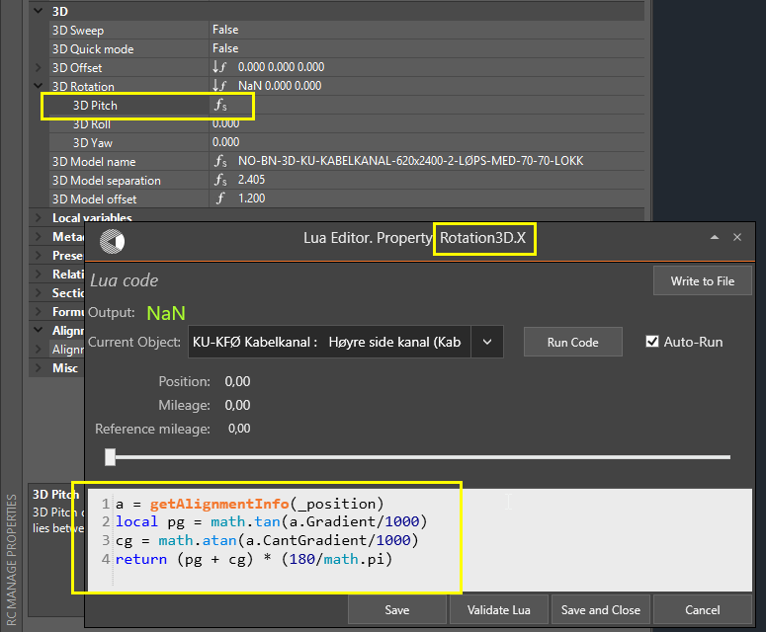
5. In order to duplicate the work in the tutorial, first create an alignment of type ‘Railway track’ with at least one curve and a countercurve, and a straight segment at each end. See other tutorials on how to draw a track from scratch using RC-CreateAlignment (‘Normalspor 1435’ is Norwegian variant name for normal gauge railway track, and ‘KO-SPO Spor’ is the RC type).  
     
   It might look like this (using RC-ShowAlignmentGeometry):  
   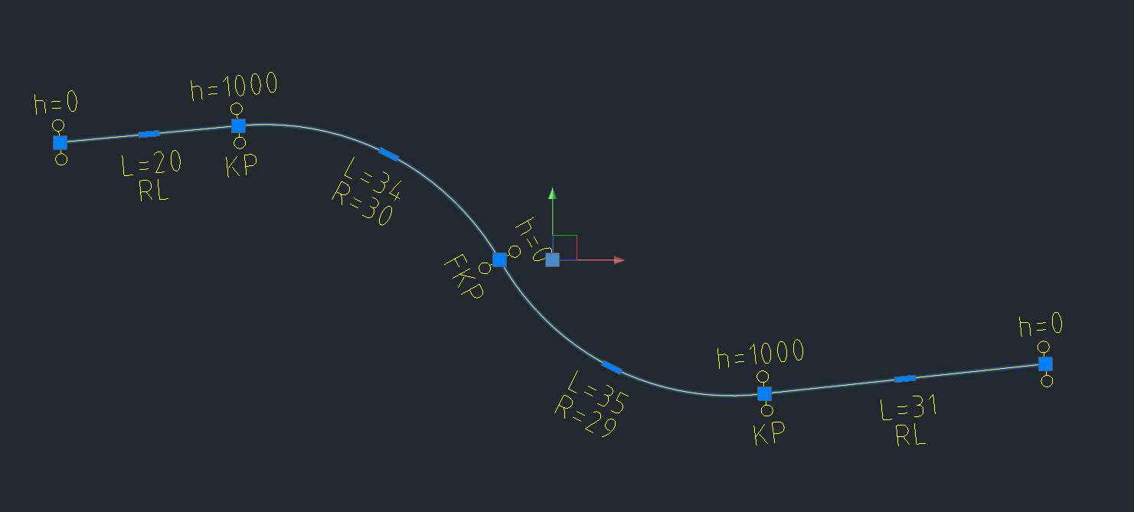
6. Open the RC-AlignmentManager tool and located the Alignment\Vertical tab. Activate the Enable Edit checkbox and enter a PVI elevation at each end of your alignment’s vertical profile. You may enter extra rows by typing a position in the empty square at the bottom of the Pos column, and then changing the default 0 elevation to your own selection.   
     
   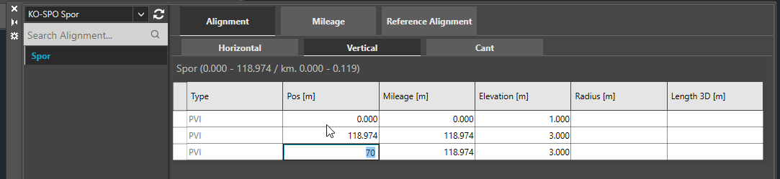  
   Try as pos 70, elevation 5 m and vertical curve radius 30 m:  
   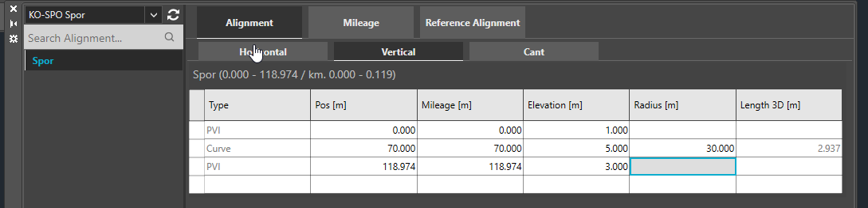  
     
   It might look like this (using RC-ShowAlignmentProfile):  
     
   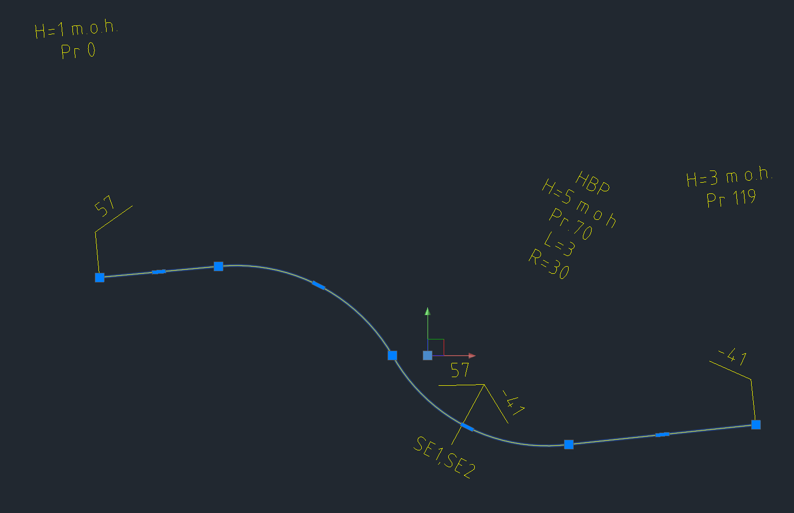
7. Add cant to your track.  
     
   First, switch to the Alignment\Horizontal tab and enable Extended View. Mark the cells in the Pos column and press Ctrl+C (copy to clipboard).   
     
   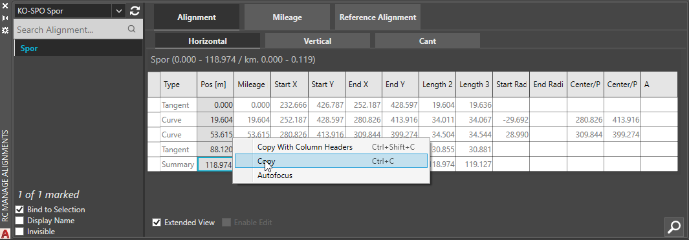
8. Then switch to the Alignment\Cant tab and enable edit again. Place your cursor in the bottom cell in the Pos column and and enter zero enough times that you now have as many rows that you found in the horizontal geometry tab. Mark all non-empty cells in the Pos column and press Ctrl+V (paste from clipboard).  
     
   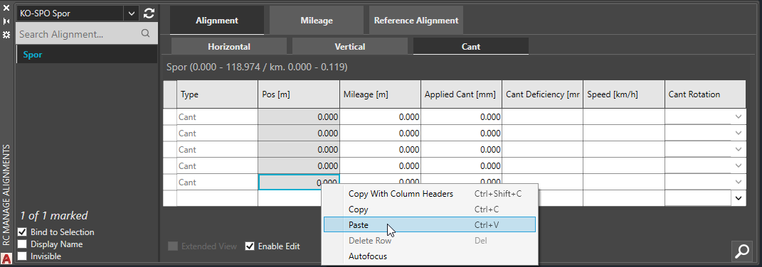  
     
   You now have a Cant datagrid with cant vertices positioned at all places where something changes in the geometry.  
     
   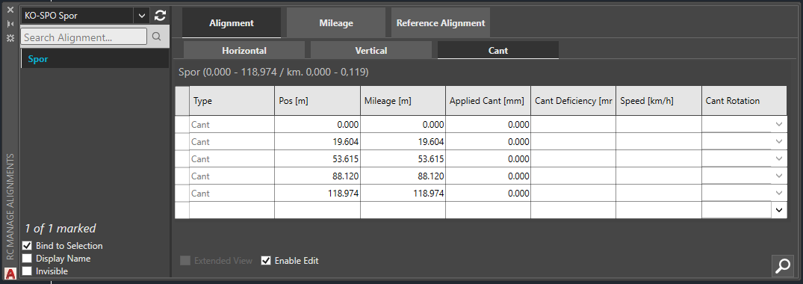
9. Enter an exaggerated cant value for each curve, for instance 1000 millimeters. Activate RC-Show3DPreview and select the alignment to see it in 3D.  
    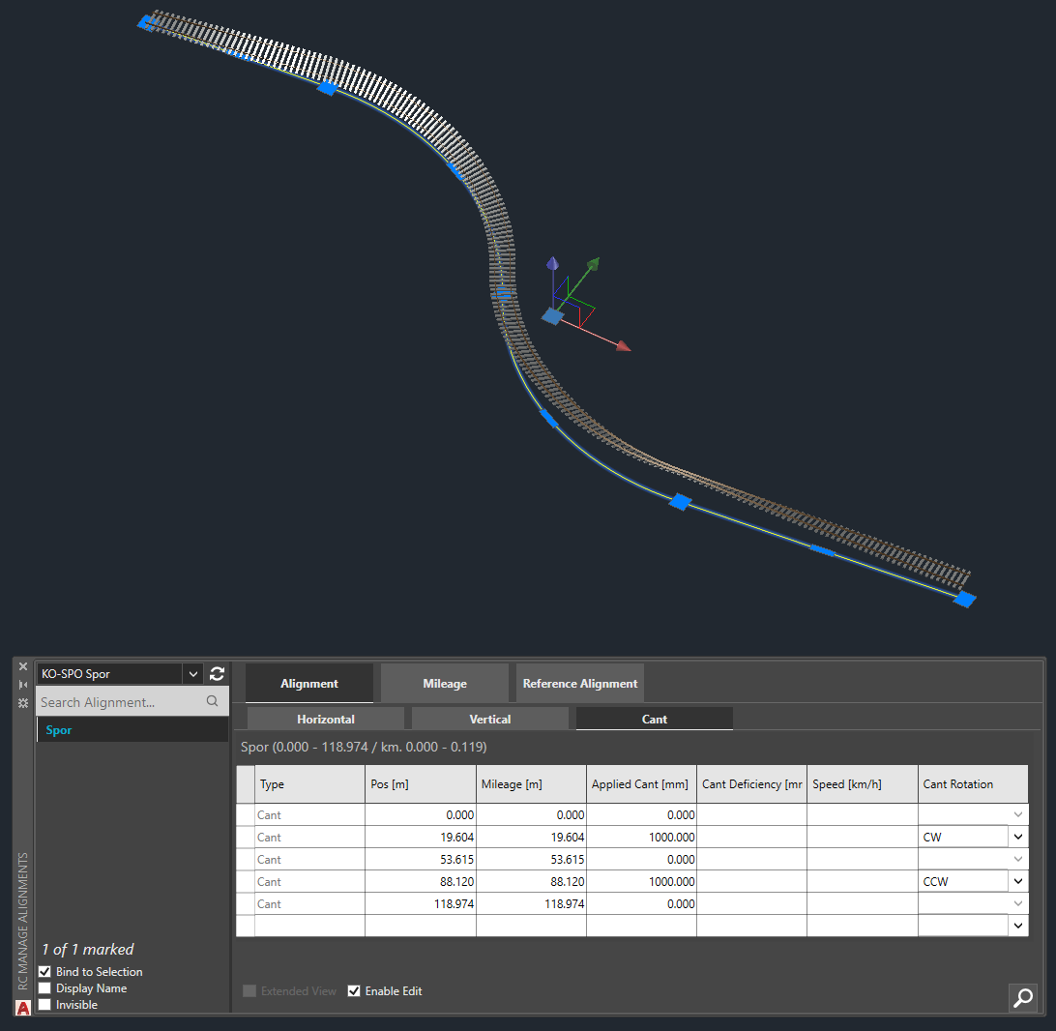  
     
   You can “Freeze” the 3D preview of the alignment by right-clicking and selecting “RailCOMPLETE Annotation => Copy annotations to drawing”
10. Adding cable ducts: Start the RC-CreateAlignment command with one of the available cable duct types:  
      
    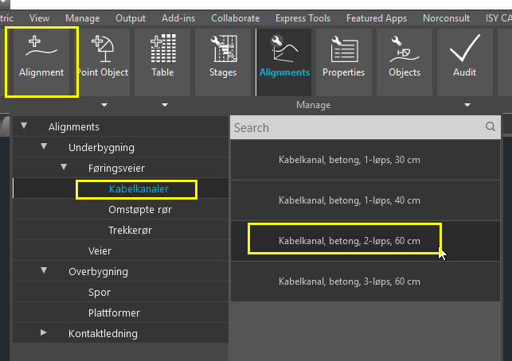  
    Instead of drawing it, select ‘O’ or press the down-arrow and select ‘Offset’:   
      
    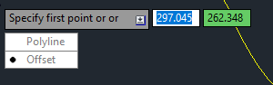
11. Enter 2.85 as sideways Offset, -0.35 as vertical Zoffset, do not Erase the track that we’re going to offset, and let the new alignment’s default layer be used as a source for its layer (instead of creating it on the current CAD layer). Make one offset to each side of the track.  
      
    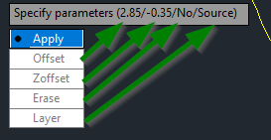  
    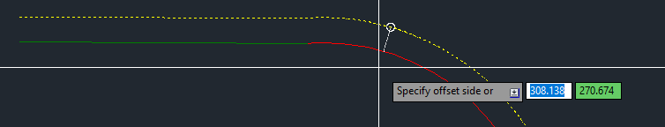
12. A 3D preview of the track-with-elevation and the two offset cable ducts may look like the illustration shown below. Note that the general elevation of both ducts follows the elevation of the lowest rail, but none of them are lifted yet when the railway track has cant (superelevation in one rail).  
      
    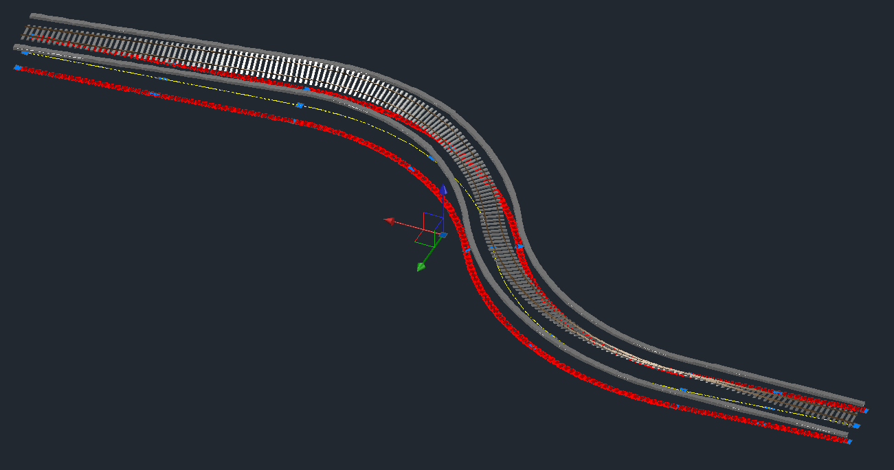
13. Then enter 1000 as cant to the outer curve for the left sided cable duct:   
      
    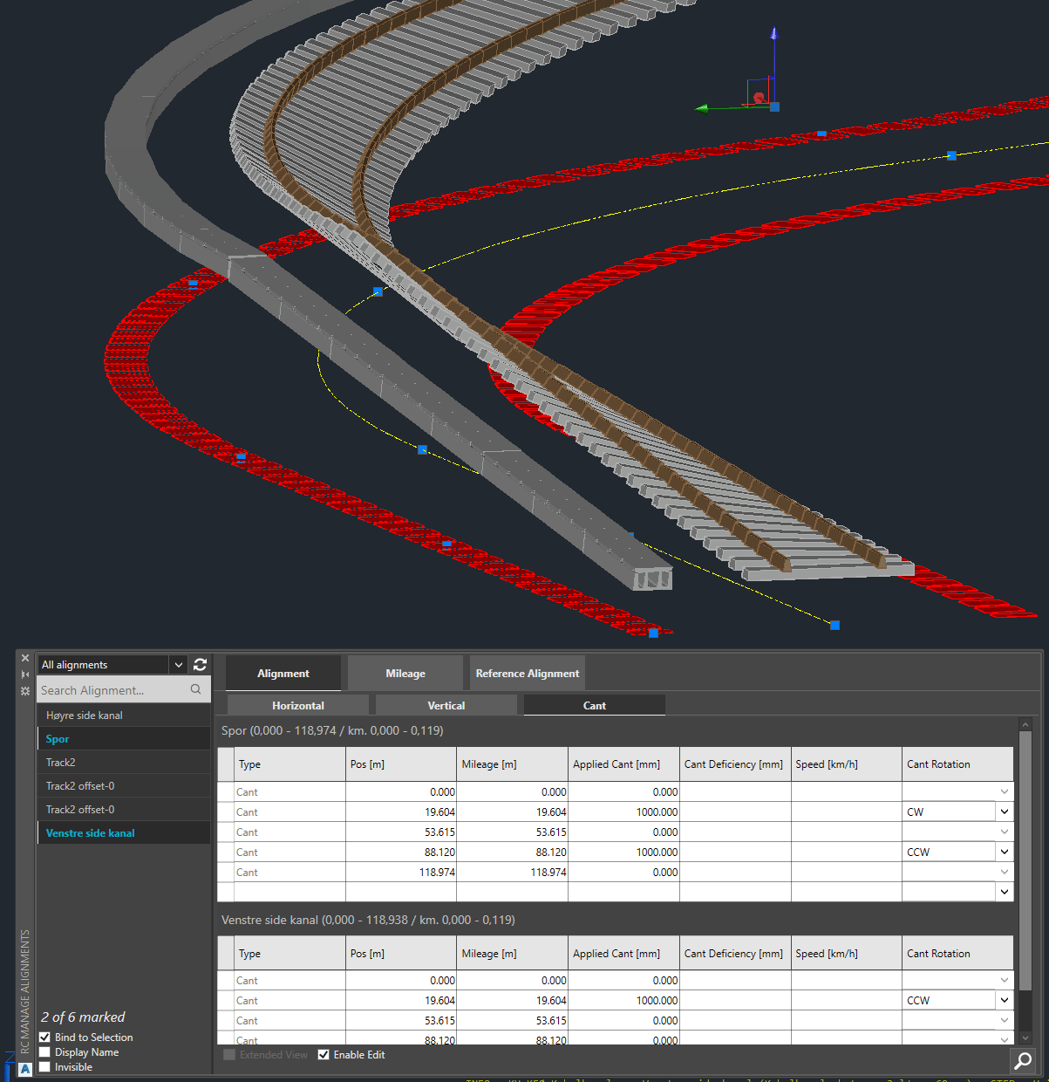
14. Enter 1000 as ‘cant’ to the outer curve for the right sided cable duct:  
      
    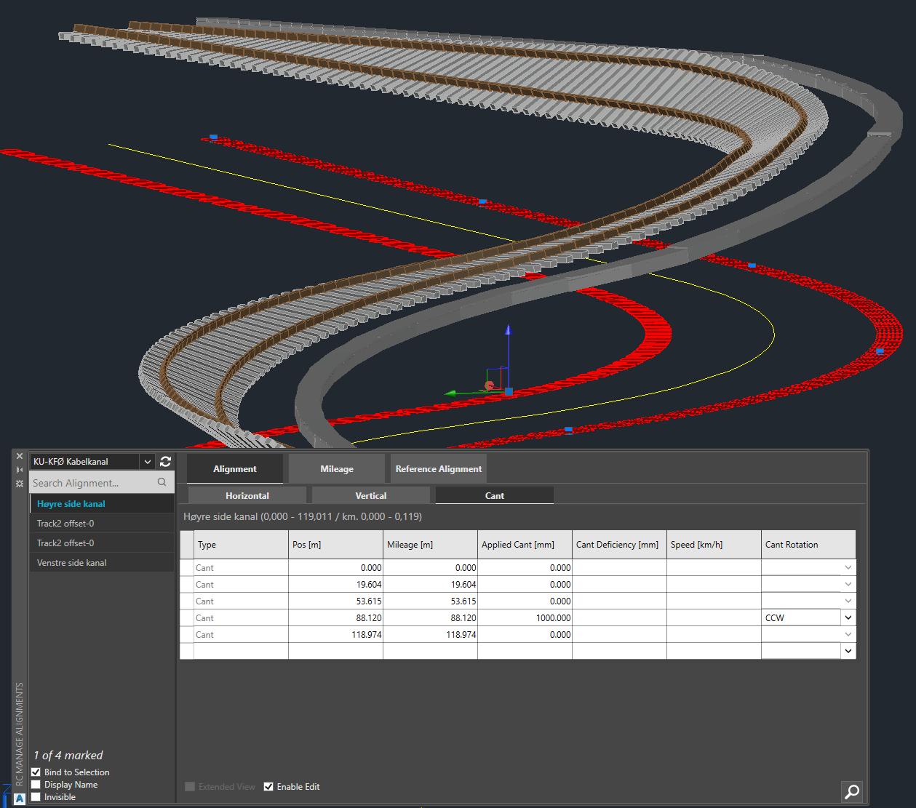
15. Note 1: The values entered as ‘Cant’ in the duct alignments are not actually used to represent cant, but just as a convenient place to store the info about lifting of the cable duct. Our formulas for lift (Offset3D.Z) and pitch (Rotation3D.X) use this info to produce the intended 3D representation of our duct.
16. Note 2: If you need the actual elevation line (for surveying purposes) then you may produce it using RC-Export3D and export just the “Model Insertion Axis” for the two cable ducts. Check the “Model Insertion Axis” box in the RC-ExportAlignments\Alignments tab before export or 3D preview.  
      
    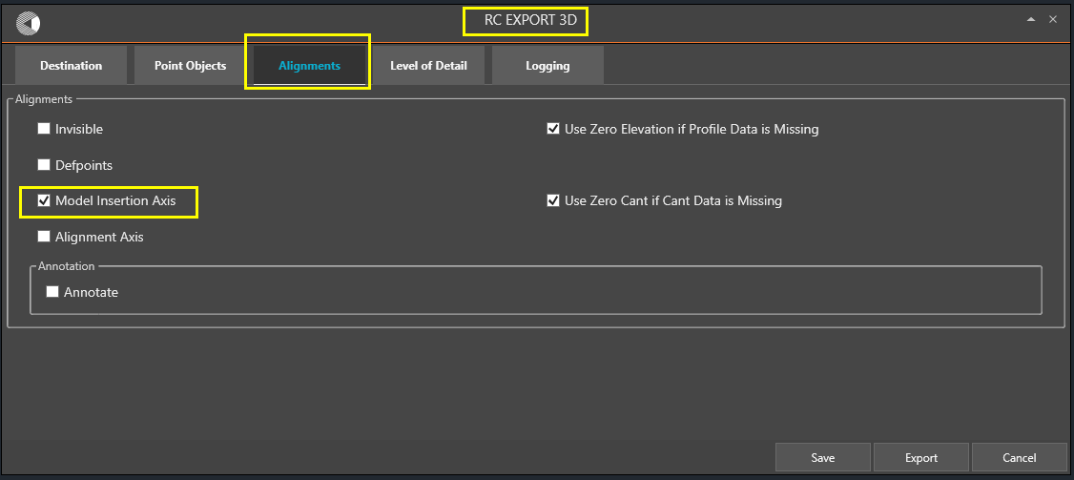
17. The two exported model insertion axes correspond to the line in space described by the 3D object models’ insertion points during 3D export, which includes all effects of formulas on Offset3D and Rotation3D.  
      
    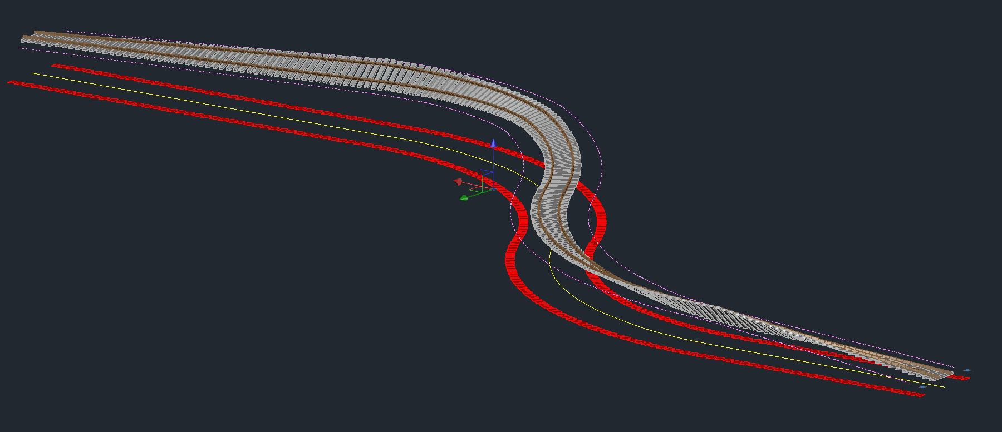
18. You can now EXPLODE (CAD system command) each of the model insertion axes in turn, then JOIN (CAD system command) all the small straight line segments (from the exported 3D alignment as an insertion-point-to-insertion-point succession of line segments) and then use RC-CreateAlignment with the now joined 3D Polyline as your pickfirst selection set and create a new cable duct from it. This has the effect of generating a new RailCOMPLETE alignment of type cable duct, with the old alignment’s model insertion axis as the new alignment’s alignment axis (and no cant data any longer). The former’s cant has been incorporated in the latter’s profile (Z coordinate) alignment axis data.  
      
    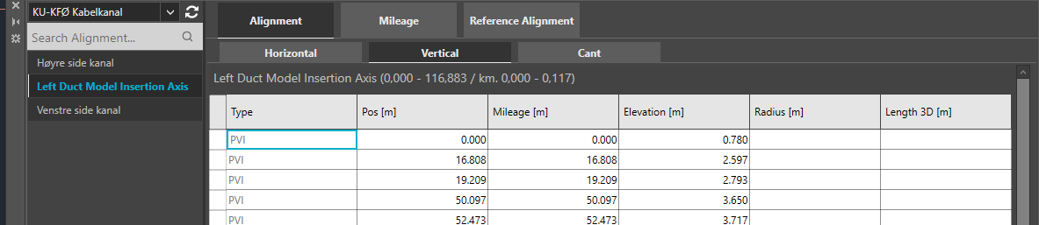  
      
    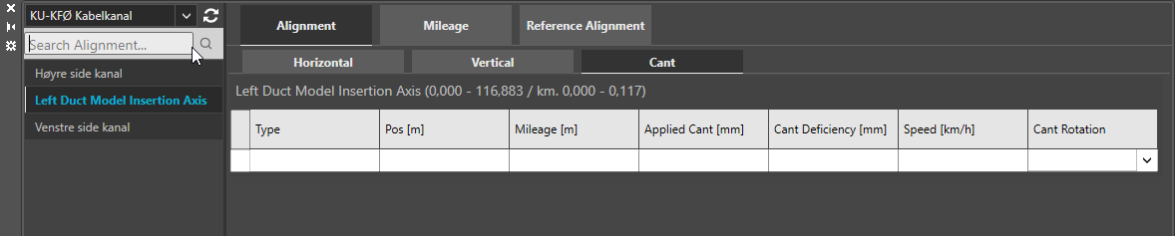  
      
    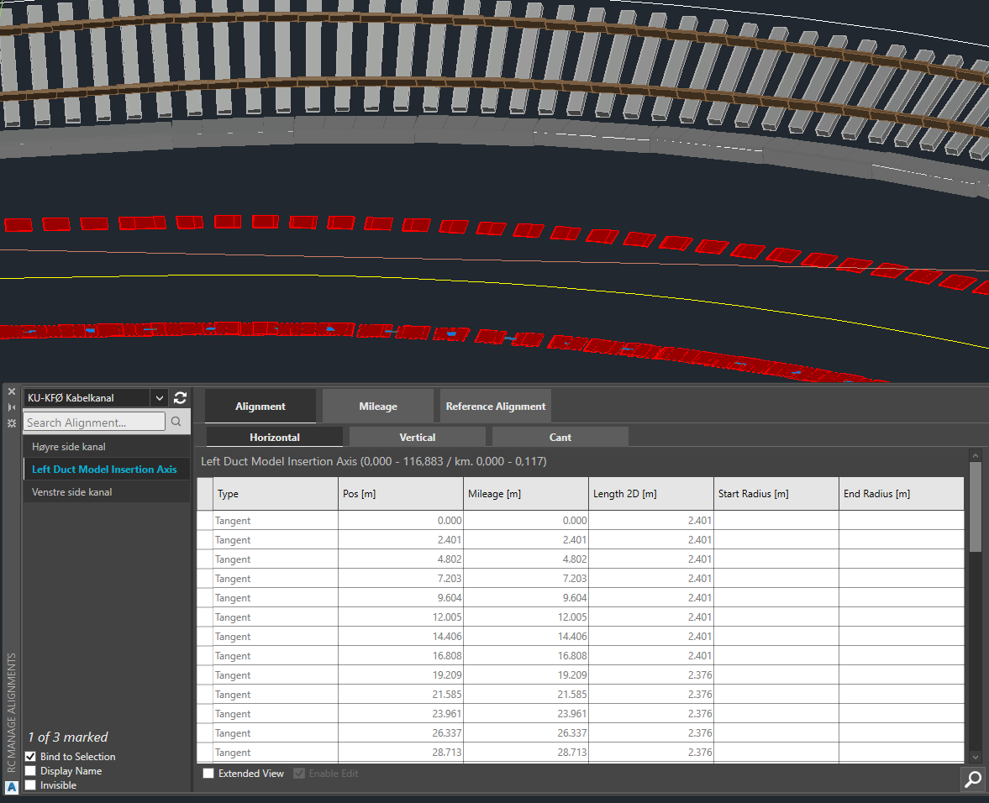
19. We hope that you have developed a sense of understanding for the Offset function and how to play with cant as extra elevation through the use of suitable formulas. We have also covered how to extract profile data which incorporates the effect of extra elevation.

Please check our website www.railcomplete.com for updates.

Corrections and suggestions are welcome to support@railcomplete.no.

Thank you for using RC Tutorials!

1. Your AutoCAD session has probably been started from a Windows shortcut of the type:  
   “C:\Program Files\Autodesk\AutoCAD 2019\acad.exe” /product ACAD /language “fr-FR” or similar (“fr-FR” means “French language, France’s version). Native AutoCAD commands may have different names in your language pack, other than the COPY, COPYBASE, FIND etc that you see in our tutorial texts. In order to instruct AutoCAD to accept the native English command name, precede the native (English) command name by an underscore character, ‘_’. For instance: ‘_FIND’ will start AutoCAD’s native ‘FIND’ command even if you are using AutoCAD with the French language pack, where the command in French is called ‘RECHERCHER’.If a command needs an argument ‘ON’, and the French menu says ‘Allumer’, then you can enter ‘_ON’ to instruct AutoCAD to use the option’s native name.